Product Specification

PoE Power Splitter with Contact Output
Model: PoE-ZRS60ATG-W+
Version 1.2
June 17, 2026

1. Product Overview
This device is equipped with one port each for power reception and power supply compatible with PoE (Power over Ethernet) technology. It can supply power to PoE-compatible devices via LAN cables, enabling easy operation of network devices in locations without power outlets or in remote areas.
Additionally, it can output power to non-PoE devices and features contact output functionality. Since no new power installation work is required, significant cost reduction can be expected.

2. Key Features
• 1 LAN port compatible with PoE power supply equipment
• 1 LAN port compatible with PoE-powered devices such as network cameras
• Compliant with IEEE802.3bt standard (UPoE), supports up to 90W power supply
• Supplies up to 72W DC power to non-PoE network devices
• 2-channel contact output control via Windows application
• LAN cable length: up to 100m × 2 (total 200m) operational support
• Compatible with existing hubs, switching hubs, and routers, contributing to equipment cost reduction

3. Product Configuration
No. | Item Name | Model No. | Qty | Note
1 | PoE Splitter | PoE-ZRS60ATG-W+ | 1
2 | Rubber Feet (Set of 4) | PA40702 | 1
3 | DIN Rail Adapter | PA40701 | 1 | Optional
4 | Mounting Angle (Set of 2) | PA40696-04 | 1 | Optional

4. Technical Specifications

4.1 General Specifications
Model | PoE-ZRS60ATG-W+
Compliance Standards | IEEE802.3bt (UPoE Type 4); PD class selectable: Class 8 (bt) / Class 4 (af/at-compatible)
Operating Temperature | -10°C ～ +50°C
Storage Temperature | -20°C ～ +70°C
Operating Humidity | 10% – 90% RH (Non-condensing)
Storage Humidity | 5% – 95% RH (Non-condensing)
Dimensions | Approx. W×D×H mm (Excluding protrusions)
Weight | Approx. 337 g
Mounting Method | Desktop, DIN rail mounting (Optional)
Cooling Method | Natural air cooling
Protection Rating | IP20 (Indoor use only)

4.2 Power Specifications
Input Voltage | IEEE802.3bt (42.5V–57V DC)
Input Power | Max. 90W (Supplied from UPoE-compatible PSE)
Output Voltage | DC 12V (11V / 12V / 13V selectable via DIP switch)
Output Power | Max. 72W (Supply to external devices)
Output Current | Max. 6A (At 12V)
Power Efficiency | ≥ 85% (At standard load)
Inrush Current | ≤ 50A (At power-on, ≤50μs)
Overcurrent Protection | Yes (Auto-recovery)
Overvoltage Protection | Yes (Auto-shutdown)
Short-circuit Protection | Yes (Auto-recovery)

4.3 Network Specifications
LAN Ports | RJ45 × 2 (Power input × 1, Camera output × 1)
Network Standard | 10BASE-T / 100BASE-TX
Transfer Rate | 10/100 Mbps Full/Half duplex (Auto-negotiation)
Compatible Cable | LAN cable (4-pair 8-core) UTP/STP Cat.5e or higher
Cable Requirement | AWG24 or less, ≤10Ω per 100m
Max Cable Length | Input side: 100m, Output side: 100m (Total 200m)
MDI/MDIX / MDI/MDIX | Auto MDI/MDIX supported
LED Indicators | Link status, Power supply status

4.4 Contact Output Specifications
Number of Contacts | 2 channels (Independently controllable)
Contact Type | Photo-MOS relay (Polarized)
Max Applied Voltage | 60V DC
Max Current | 0.1A
Max Power | 0.1W
ON Resistance | 0.5Ω (Typical)
OFF Resistance | ≥100MΩ
Response Time | ON: 1ms, OFF: 0.6ms (Typical)
Isolation Method | Optical isolation (Isolated from internal circuit)
Initial State | OFF (At power-on)
Control Method | Windows application (via LAN)
Terminal Type | Screw terminal block

5. External View & Dimensions
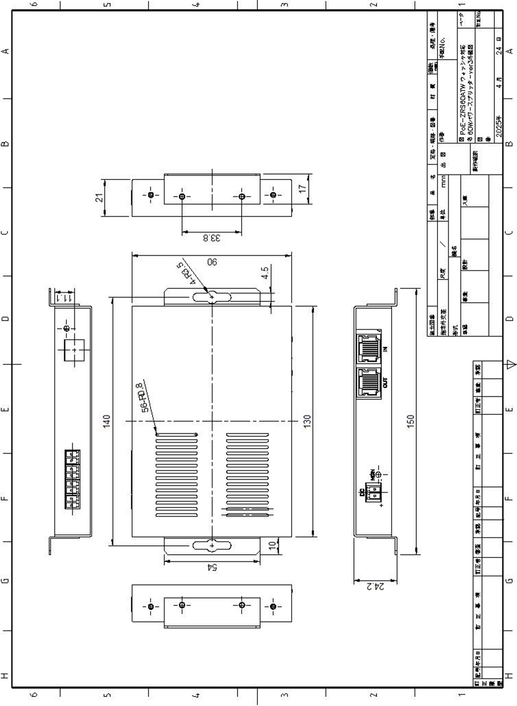
※ Please refer to the following for external view and detailed dimension drawings

5.1 Description of Main Components
[Front]
• Power Port (PoE IN): Port for receiving power from PSE
• Camera Port (PoE OUT): Port for supplying power to PD
• LED Indicators: Link status, Power supply status
[Rear]
• DC Output Terminal: Power supply terminal for non-PoE devices (Screw terminal)
• Contact Output Terminal 1, 2: Contact output terminals (Screw terminal)
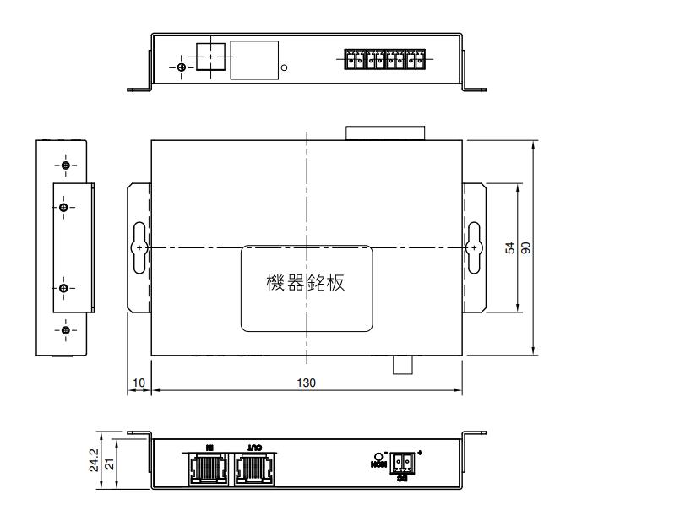
• Mounting Holes: For wall mounting, DIN rail mounting
[Image Placeholder] Rear Panel Detail (Recommended size: 600px × 400px)

6. Connection Example & System Configuration

6.1 Basic Connection Example
An example of application to a general network camera system is shown below.
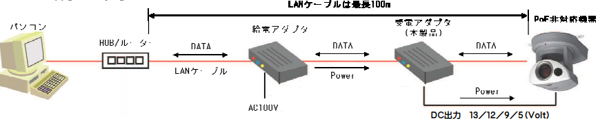

[Image Placeholder] System Connection Diagram (Recommended size: 700px × 400px)

6.2 Contact Output Connection Example
An example of LED lighting control using contact output is shown below.
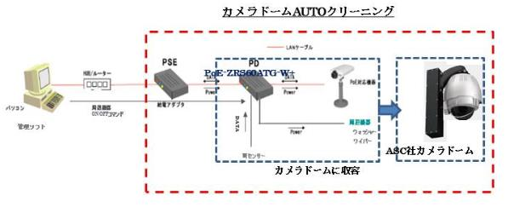
[Image Placeholder] LED Connection Example (Recommended size: 500px × 350px)

※ Contact output is isolated from the internal circuit
※ Contacts are initially OFF at power-on
※ Do not use with voltage exceeding the maximum applied voltage

7. Software Specifications

7.1 Control Software Overview
A dedicated Windows application is used to control the contact output of this product. It provides functions such as ON/OFF control of contact outputs 1 and 2 via LAN network, schedule settings, and log management.

7.2 Operating Environment
Supported OS | Windows 10 / Windows 11 (64-bit recommended)
CPU | Intel Core i3 or higher (Recommended: Core i5 or higher)
RAM | 4GB or more (Recommended: 8GB or more)
HDD | 100MB or more free space
Display | 1280×768 or higher recommended
Network | 10/100 Mbps Ethernet
.NET Framework | Version 4.7.2 or higher
Others | Administrator privileges required for installation

7.3 Main Functions
[Basic Control Functions]
• Individual ON/OFF control of contact outputs 1 and 2
• Real-time status display
• Manual control mode
• Automatic device detection
[Schedule Function]
• Automatic ON/OFF by date and time
• Repeat settings (Daily, Weekly, Monthly)
• Register and manage multiple schedules
• Enable/Disable schedule switching
[Log Management Function]
• Record and display operation history
• Export in CSV format
• Filter and search function
• Log retention period settings
[Multi-device Management Function]
• Centralized management of multiple devices
• Device name settings
• Group management function
• Quick switching from list

8. Safety Standards & Certifications

8.1 Compliance Standards
PoE Standard | Compliant with IEEE802.3bt (UPoE Type 4)  Class 8 (bt): up to 90W input / 72W output with a bt Type 4 PSE  Class 4 (compatible): works with 802.3at/af PSE; PD input limited to approx. 25.5W (at) / 13W (af)  Note: full 72W output is not available on af/at PSEs (reduced-power mode).
Ethernet Standard | IEEE802.3 (10BASE-T) IEEE802.3u (100BASE-TX)
EMC Standard | EN55032 Class A (EMI), EN55035 (EMS)
Safety Standard | IEC 62368-1 EN 62368-1
RoHS Directive | EU RoHS compliant
REACH Regulation | REACH compliant

8.2 Environmental Standards
Usage Environment | Indoor use only
Installation Location | Avoid direct sunlight, well-ventilated location
Altitude | 2000m or less
Pollution Degree | 2
Overvoltage Category | II

9. Reliability Data

9.1 MTBF / MTBF (Mean Time Between Failures)
MTBF Value | ≥ 100,000 hours
Calculation Conditions | 25°C, Rated load
Calculation Method | MIL-HDBK-217F

9.2 Environmental Test Data
High Temp. Operation | +50°C, 168 hours operation; Result: Pass
Low Temp. Operation | -10°C, 168 hours operation; Result: Pass
Thermal Cycle | -10°C to +50°C, 10 cycles; Result: Pass
Damp Heat | +40°C, 90%RH, 96 hours; Result: Pass
Vibration Test | 5–200Hz, 1.96m/s², 2 hours each axis; Result: Pass
Shock Test | 30G, 11ms, positive and negative directions on each axis; Result: Pass

10. Maintenance & Support

10.1 Warranty Period
The warranty period for this product is one year from the date of purchase. If the product fails under normal use during the warranty period, it will be repaired or replaced free of charge.

10.2 Maintenance
• Regular visual inspection (dust removal, terminal tightness check)
• LAN cable connection status check
• LED indicator check
• Regular backup of log files

10.3 Consumables & Replacement Parts
Rubber Feet | Model: PA40702; Replacement: When deteriorated
Internal Fan | Not applicable (Fanless design)

10.4 Contact Information
For inquiries regarding products, technical support, and after-sales service, please contact your dealer or our support desk.

11. Precautions
[WARNING]
• This product is for indoor use only. Do not use outdoors
• Do not disassemble or modify. It may cause failure or fire
• Do not use power sources other than specified
• Do not use contact output with voltage exceeding maximum applied voltage
[CAUTION]
• Do not install in high temperature/humidity, direct sunlight, or dusty locations
• Do not install in locations subject to vibration or shock
• When plugging/unplugging cables, hold the connector part
• Use LAN cables of specified category (Cat.5e or higher)
• Total LAN cable length should be within 100m for both input and output sides

12. Revision History
Rev. | Date | Author | Description
1.0 | 2026-01-17 | Engineering | Initial release
1.2 | 2026-06-17 | Engineering | Updated output voltage, PoE class description, EMC and safety standards

Contents are subject to change without notice
This document is confidential

